Document Number | HWUG2
Document Title | Health and Well-being Assessment Guide
Department Ownership | Health and Wellness
Document Type | User Guide
Department Owner | Jason Vowles
Document Author | Derrick Chan
Last Edited By | Derrick Chan | Lasted Edited On | 19/05/2015

Purpose

The purpose of this document is to describe the methods that must be used when completing REDiMED Health and Wellness Assessment. This document is used to ensure the quality and results are reliable and of REDiMED standard.

A REDiMED Health and Wellness Assessment consist of a Medical Assessment, Spirometry, and strength and endurance testing.

Scope

This applies to all REDiMED and Alliance Clinic staff who undertake Pre-Employment Medicals.

Reference Documents

National Safety and Quality Health Service NSQHS Standards
Codes of practice

Definitions

Procedure – A document that details the purpose and scope of an activity and specifies what is to be done and by whom, how, when and why an activity is to be carried out. A procedure is a component of a process.

Forms – Various forms are used besides the PIR to provide records of the System’s operation and to address any issues or non-conformance arising in the Quality Management System relating to the work instructions, procedures, user manuals, reference tools, learning guides and any other non-QA related issues.

Strength and Fitness - testing involves cardiovascular fitness, flexibility, core strength, and lower and upper limb function muscular endurance testing to give an indication of a candidate’s strength and fitness.

Flowcharts (Other Images)

Procedures

File Order
- Booking form
- Identification (if applicable)
- Medical History
- Health and Wellness Assessment
- Spirometry print out

- Medical History

- Patient is to complete the Medical History Form prior to assessment taking place.

- Ensure consent declaration is signed and witnessed prior to commencement of the medical assessment. Witness can be the Exercise Physiologist or Receptionist.

- Ensure the bottom of every page of the medical history is initialed by the patient prior to completing the medical assessment.

Medical History Review

- Medical Histories MUST be reviewed and queries by the Exercise Physiologist/Nurse/Physiotherapist and GP.

- Every “yes” response MUST have an examiner comment in the space provided.

- Information required is as below:
  - Diagnosis of injury/Illness (i.e lower back muscle strain)

  - If no formal diagnosis is reported state this (no formal diagnosis provided)
  - Date of injury/illness
  - Treatment received (physio/surgery etc) and how currently managed (via exercise etc)
  - Current presentation (i.e no pain or restriction reported)

- Candidate should also be questioned verbally ‘Are there any other current or previous injuries, illnesses or workers compensation claims not included in this Medical History?’

4. Medical Assessment

- Prior to beginning medical assessment ensure each page with the below box needs the candidates full name and date of birth written.

Weight

- Instruct candidate to remove shoes and items from pocket and step on to the scales.
- Weight should be recorded in kilograms (kg).
- Completed by an Exercise Physiologist or Nurse.

Height

- Instruct candidate to remove shoes and stand with heels, back and head up against the wall underneath the measuring tape.
- The tape should be rolled down until level with the wall and flat on the candidate’s head.
- Height recorded in centimeters (cm).
- Completed by an Exercise Physiologist or Nurse.
BMI

- BMI is the individual’s weight divided by their height in meters squared.
- BMI should be recorded to 1 decimal place.
- Records BMI in the box indicated and tick the classification they fall into.
- This number can classify the individual as underweight, normal, overweight or obese
- Completed by an Exercise Physiologist or Nurse

Waist Circumference

- Place tape measure around the smallest part of the candidate mid-section for females and in line with the navel for males.
- Record waist circumference in centimeters (cm).
- Completed by an Exercise Physiologist or Nurse.

Hip Circumference

- Place tape measure around the largest part of the candidate’s gluteal region.
- Record hip circumference in centimeters (cm).
- Completed by an Exercise Physiologist or Nurse.

Waist to Hip Ratio

- Divide the waist measurement by the hip measurement to derive the waist to hip ratio.
- Record to two decimal places.
- Record Waist to Hip Ratio in box provided and tick the classification they fall into.
- Completed by an Exercise Physiologist or Nurse

Blood Pressure Test

- Instruct candidate to relax left arm on the bench with palm facing upwards (supine).
- The appropriate cuff type should be considered. Short cuff for an individual with a smaller arm, long cuff for personnel with larger arms and the large maroon cuff for candidates with elevated Blood Pressure or larger arms.
- The cuff should be fastened around the left arm with the arrow in alignment with the artery.
- Pump up cuff and then slowly release the air until the Korotkoff sounds can be heard and then a blood pressure reading can be taken.
- If blood pressure is classified within the ‘normal’ ranges then the medical may proceed.
- If blood pressure is between 150-168 Systolic and 90-100 Diastolic please use the chain of events below.

- If blood pressure falls into any of the following 170/102, >180/>110 or >160/<70 please use flow chart below.

- Completed by an Exercise Physiologist or Nurse.

Heart Rate Test

- With palm facing upwards (supine), two fingers should be placed on the distal radial side of the forearm.
- Pulse should be counted for fifteen seconds and then multiplied by four resting heart rate to derive the in beats per minute (bpm).
- Completed by an Exercise Physiologist or Nurse.

Random Blood Glucose Tolerance Testing
Please refer to specific glucometers guide.
Spirometry Test
- The candidate’s information is required to be put into the spirometry machine correctly (DOB, height, ethnicity, gender and smoking status).
- Instruct the candidate to select a tube and place it in the blower. Tester must not touch candidates white tube.
- Instruct the candidate to take a maximum breath in, lightly bite down on the tube, seal their lips around the tube and forcefully blast out their breath and hold on her as long as possible.
- Instruct candidate to not breathe in through the tube.
- After each attempt tester must examine the graph to ensure it has a strong peak at the beginning and discard the attempts that do not meet the requirements.
- Tester must ensure they have three results that are within 0.15 of each other before candidate can cease test.
- The tester must ensure both FVC and FEV1 have three results within 0.15L of each other before the candidate can cease testing.
- A result equal to or above 80% for the FVC, FEV1 and FVC/FEV1 ratio can be considered normal.
- Physiologist is to review and explain the results to the patient.
- Completed by Exercise Physiologist or Nurse.

Urinalysis
- Testing to be performed on an urine sample.
- Use urinalysis strips and dip into the sample and rest on side to remove any excess.
- Wait 1 minute or manufacturers guide and compare to normal results.
- Document any abnormalities.

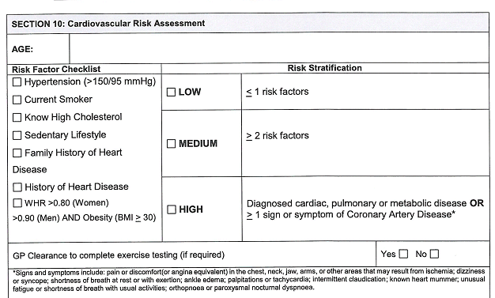
Cardiovascular risk assessment
- Review medical history, medical assessment and question candidate to determine if candidate has any of Cardiovascular Risk Factors.
- Tick the relevant boxes for the risk factors they have.
- Tally the risk factors and tick the risk rating they fall into (Low, Medium or High)
- Ensure the candidate’s age in placed in the box indicated.
- Complete by a General Practitioner

Strength and Fitness Assessment

Ask the worker to read and sign the strength and fitness assessment consent form on page 2 of the Health and Wellness Assessment. If this is not signed or the worker states there is a reason they cannot perform the work fitness assessment today, the assessment is ceased.
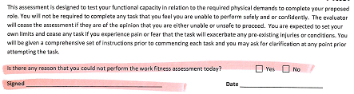

Range of Motion Assessment
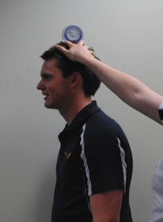 | Range of motion is visually assessed, unless the candidate reports a previous injury in the last 5 years (beyond a sprain or strain) or reports pain with a movement.  If the visual range is within normal range please tick the required box, if during visual assessment it is deemed restricted please measure and report number in box. For measured range please report the number in the box associated with that movement.  ** See below for range of motion instructions.  Note: If pain is reported proceed to extra testing for that body region.
Hamstring Flexibility
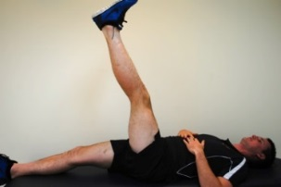 |  | The candidate lies supine with legs extended. The tester places the bubble inclinometer on the anterior tibia. The candidate then lifts their leg off the bed as far as they can, maintaining full knee extension on both legs. Perform twice, record best measurement and repeat for the other side. Record the best measurement for right and left next the L and R below the diagram. Circle the rating range that they fall into.  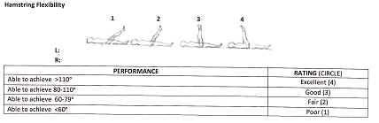

Upper Limb Strength Test: Grip Strength
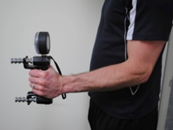 | The candidate is to sit/stand with elbow tucked in at side and flexed to 90°. Place the hand dynamometer in the candidate’s hand and instruct candidate to provide maximal grip force without rapid wrenching or jerking. Test each hand 2 times, record each and determine the mean. You record the normal range for right and left hands for their age group, their dominate hand, age and the range they fall into (Above, within, below normal range).
Core Strength: Prone Bridge
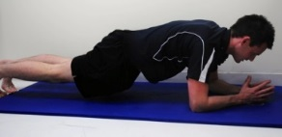 | Instruct the candidate to have their forearms and toes on the floor with elbows directly under their shoulders and assume the plank position. The tester is to ensure that the candidate keeps the spine in a neutral position. Candidate is to hold position for as long as possible to a maximum of 120 seconds, and the time is recorded. Circle the rating they fall into (i.e 95seconds = Good). Report effort used, pain experienced or if test is ceased due to poor technique.  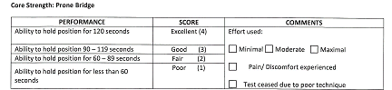
Push Up Test
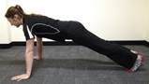 | Instruct the candidate to lay prone on the ground/mat. Arms are placed shoulder width apart. Instruct the candidate to maintain a neutral spine and use their arms to push up. Slowly lower down. Candidate is to complete as many repetitions as possibly.  Use table to on paperwork to determine score.

3 Minute Step Test
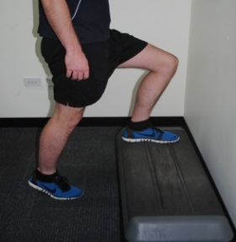 | The step height is set at 300 mm and the metronome set at 96 bpm. The candidate steps for 3 minutes, instructor must record heart rate at each 60 second interval in the table provided. After 1 minutes rest record the recovery heart rate in the table.  During the test, the tester observes candidate to look for signs of breathlessness, chest pain, dizziness etc. If they exceed 85% max HR, proceed only with doctor’s consent.  Use the recovery heart rate to determine the rating they fall into according to their age and gender.  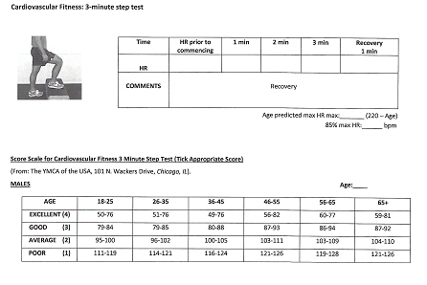  Ensure the Age maximum heart rate (220-age) and 85% max heart rate is recorded below the box.
Squat Test
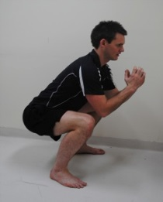 | Instruct candidate to perform as many full depth squats in 1 minute. Tester must ensure that for each repetition the candidate reaches 90° knee flexion with their feet flat on the ground otherwise repetition does not count towards the total.  Record total number.

Health and Well-Being Report

Cardiovascular Risk Rating: Transfer result from page 1 of the Health and Wellness Assessment

Diabetes Risk Rating: Transfer result from page 1 of the Health and Wellness Assessment

Strength and Fitness Summary: Transfer results from page 2 and 3 from the Health and Wellness Assesment into the appropriate columns.
- Flexibility: hamstring flexibility
- Core Strength: core strength:Prone bridge
- Cardiovascular Fitness: Cardiovascular fitness: 3 minute step test
- Muscular Strength and Endurance: Push up test plus Squat test

Recommendations
Check any boxes that apply to the client. Write any further health and wellness recommendations on the lines included.

Other Comments
Any other relevant comments

Fact Sheets Provided
List the name of any fact sheets that were given to the client at the time end of the Health and Wellness Assessment.

Name, sign and date the bottom of the Health and Wellbeing Assessment.

Returning Files
Once the REDiMED Pre-employment medical is completed please ensure all the paperwork is fully completed and in the following order:

- Booking form
- Medical History
- Medical Assessment(s)
- Functional Capacity Assessment
- Spirometry print out

Completed files need to be scanned in and emailed to REDiMED within 24 hours of the candidate’s appointments.

Failure to meet the requires KPI’s, return paperwork within required times or completing paperwork and testing to the standards outlines above do so will result in consequences outlines in the Service Agreement.
Range of Motion Guide
Range of Motion must be measured for a region if any of the below are met
- Candidate has had an injury in the last 5 years
- Workers Compensation injury in the last 10 years
- Injury in the last 10 years with associated below average general results (i.e lower back injury with poor core strength)
- Previous injury that could affect a specific job requirements (ie shoulder bursitis and a Silverchain, knee injury and a Scaffolder)
- If Pain noted with testing excluding general muscle pain

Cervical

Movement | Description
Flexion | Tester to stand side-on and place inclinometer on the top of candidates head. Instruct to stand straight, look down at the ground, bringing the chin to the chest. When visually assessed observe from side on. | 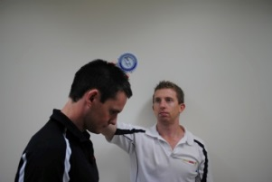
Extension | Tester to stand side-on and place inclinometer on the top of candidates head. Instruct to stand straight and look up towards the roof as far as comfortable. When visually assessed observe from side on. | 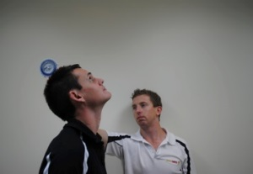
Lateral flexion | Tester to stand behind candidate with inclinometer on head. Place hand on right shoulder to prevent it from being raised and instruct the candidate to tilt their head to the left so the ear moves towards the shoulder. When visually assessed observe from in front or behind. | 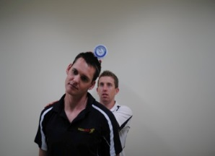
Rotation | Stand in front of the candidate and instruct to look over one shoulder, then back to the middle and to the other shoulder. Ensure the trunk is not rotated | 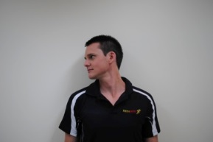

Back

Extension | Tester to stand side-on and instruct the candidate to stand tall and extend backwards from the hips. Ensure the hips and knees are not pushed forwards. When visually assessed observe from side on. | 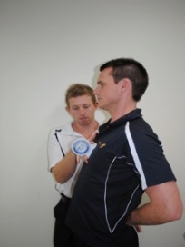
Lateral flexion | Tester to stand behind the candidate and place the inclinometer on the lateral aspect of the right upper arm. Instruct candidate to slide left hand down outside of thigh as far as comfortable. Ensure the right arm is kept by the side and the hips aren’t pushed out to the right. When visually assessed observe from front or behind. | 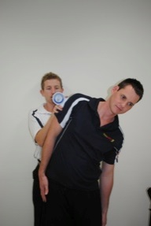
Forward Flexion | Tester to stand side on. Instruct the candidate to reach down to the ground keeping their legs straight and feet shoulder width apart. Record the distance from the ground. | 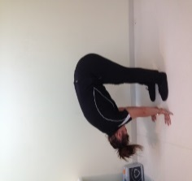
Rotation | Tester to stand front on, instruct the candidate to place arms crossed over chest and twist through the trunk region while keeping the hips neutral | 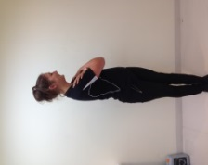

Shoulder/Elbow

Flexion | Tester to stand side on and instruct the candidate to stand straight with their arms by their side, keep the elbow straight and bring the arm forwards up past their ear. Repeat for opposite side. | 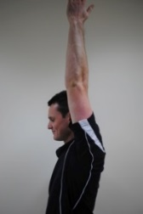
Abduction | Tester to stand front on, instruct the candidate to keep the elbow straight and abduct the arm as far as comfortable. Ensure shoulders stay level. | 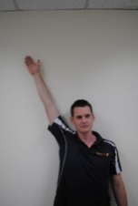
External Rotation | Tester to stand side on, instruct the candidate to place their right arm in 90 degrees shoulder abduction and 90 degrees elbow flexion. Place the goniometer on the candidate’s wrist and support the elbow while the patient fully externally rotates the shoulder. Repeat on the left side.
Internal Rotation | Tester to stand side on, instruct the candidate to place their right arm in 90 degrees shoulder abduction and 90 degrees elbow flexion. Place the goniometer on the candidate’s wrist and support the elbow while the patient fully internally rotates the shoulder. Repeat on the left side.
Flexion | Tester to stand side on and use the goniometer when measuring – place the center of the goniometer over the lateral epicondyle and instruct the candidate to keep elbows by their side and bring hand up to shoulder (flex at the elbow). Can be visually assessed from side on. | 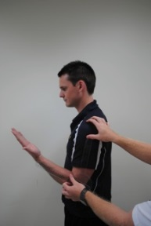

Wrist
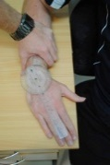
Pronation | Instruct candidate to sit with elbow on a desk, elbow tucked in by the side and bent at 90 degrees. The wrist should hang over the edge of the desk. Place the inclinometer on the dorsal aspect of the hand and instruct the candidate to turn the palm down towards the floor. | 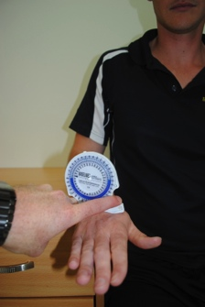
Supination | Instruct candidate to sit with elbow on a desk, elbow tucked in by the side and bent at 90 degrees. The wrist should hang over the edge of the desk. Place the inclinometer on the palm of the hand and instruct the candidate to turn the palm up towards the roof. | 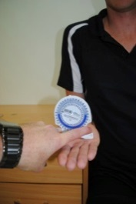
Flexion | Instruct the candidate to rest elbow on the desk with forearm vertical and palm neutral and thumb towards shoulder. Place the inclinometer on the dorsal aspect of the hand and instruct the candidate to bring the palm down towards the floor. | 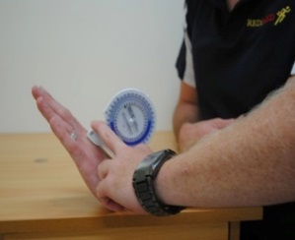  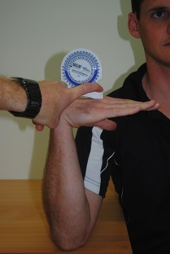
Extension | Instruct the candidate to rest palm face down on desk, elbow flat on the desk and close to body. Instruct the candidate to raise palm off the desk without lifting elbow.
Ulnar deviation | Candidate to start in same position as for extension. Tester places small goniometer with the center of the goniometer over the carpals and the midline running through the 3rd metacarpal and the middle of the arm. Instruct the candidate move hand away from the body, without shifting the arm or wrist. | 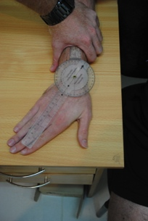
Radial deviation | As for ulnar deviation, instruct the candidate to move the hand towards the body.

Hip/Knee/Ankle

Flexion | Instruct the candidate to lay on their back with legs straight. Place the inclinometer on the anterior thigh and instruct the candidate to bring their knee to their chest (without assistance from the hands) | 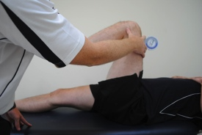
External rotation | Instruct the candidate to sit on the edge of a plinth, feet hanging over the edge, with knees and feet together. The examiner places a hand on the outside of the left knee to prevent it from moving laterally. The candidate brings the right leg back and takes the left foot across the body. The inclinometer is placed on the lateral aspect of the lower leg | 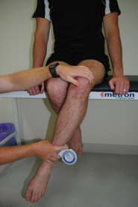
Internal rotation | As for external rotation, however the foot is taken away from the midline. Ensure the hip is not lifted.
Flexion/  Extension | The candidate lays face down with feet hanging over the edge of the plinth to ensure the leg is at 0°. The inclinometer is placed on the posterior lower leg and the candidate curls the leg towards the backside. | 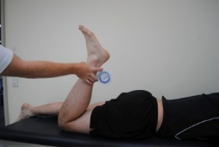
Rotation | Sitting on the plinth, the candidate rotates their ankles in both directions. | 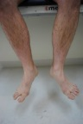
Plantar/  dorsiflexion | Sitting on the plinth with legs dangling, the foot is plantar/dorsiflexes. | 